The Matrimony Service Book

Manglish Version for the Matrimony Service
of
St. George Jacobite Church, Seattle

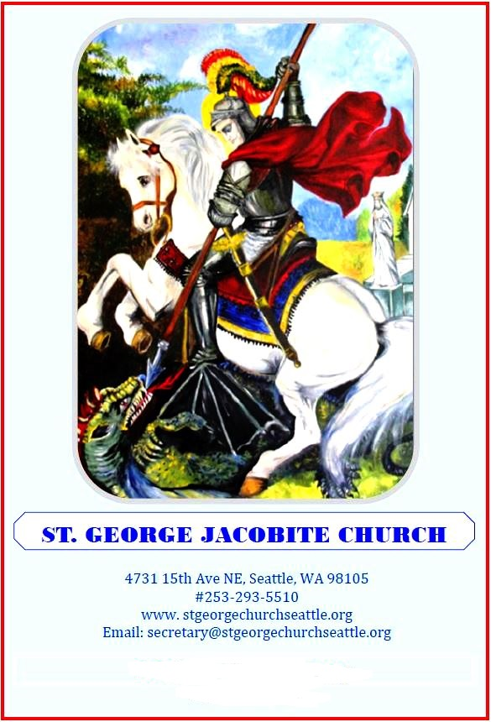

“Blessed are they which do hunger and thirst after righteousness for they shall be filled”.

THE MARRIAGE SERVICE OF THE
MALANKARA ORTHODOX SYRIAN CHURCH
Marriage is a sacrament, a mystery that involves an initiation into a new life by a man and a woman. Initiation implies the orientation to participate in the practice of
sharing each other’s life. True participation involves the love that Christ had for His bride, The Church. Marriage relationship at its best is mutual self-giving love.
Just as God blessed the first family commanding Adam and Eve to be fruitful and multiply, so the Church gives her blessing to the union of man and woman.
Our Lord Jesus Christ blessed marriage by His presence at Cana of Galilee. Marriage is not only a state of nature, but a state of grace.
Married life is a special vocation requiring charisma from the Holy Spirit and this gift of grace is conferred through the sacrament of Matrimony.

The Sacrament of Marriage is a blend of rich biblical traditions, teachings, and practices of the early church in Palestine, Syria and the ancient customs of South India.
The order of Holy Matrimony, ceremony of the crowning, used by our church was compiled, arranged, and revised by St. James of Edessa (708AD) and other doctors of the
holy church who had received it from the Holy ancient tradition of the apostolic church.

The Marriage service is divided into two parts, formerly held separately but now celebrated in immediate succession.
The preliminary part is the "Office of Betrothal" (blessing of the rings) and the second part is the "Office of the Crowning" (blessing of crowns) which constitutes the
sacrament proper.

I. The Engagement - Blessing of the Rings

The blessing of rings by the hands of the priest is an outward sign that the two partners join in marriage of their own free will and consent without which there can be no
Christian Marriage. The ring is a symbol of contract, placed on the bride and the groom by the priest representing God and the Church.
It recalls the act of Isaac putting gold ornaments on Rebecca.

II. The Marriage - Blessing of the Crowns
The second part of the service is the blessings of the crowns and the ceremony of coronation. On the heads of the bridegroom and bride, the priest places
crowns of gold (here chains with cross. This signifies the special grace the couple receives from the Holy Spirit before they establish a new family, or a house church.
They are the king and queen of the family sharing the joy, the responsibilities and the sacrifice involved in "reigning" together.

This is followed by the tying of the "Thali" (Minnu) an Indian custom incorporated in the churches of South India. The Minnu is a small gold pendant stylized as a heart
with a cross on it. This is placed on a silk thread made by interweaving seven threads taken out of the "Manthrakodi", the bridal sari given by the groom's family.
The silk thread with the minnu on it is tied around the bride's neck by the groom. This is a symbolic act, accepting her as his own, signifying the life-long inseparable
bond established in marriage.

Immediately after this, the place of the bride's aunt who stands behind the bride, is taken by a woman from the bridegroom's family. From now onwards she will be an
advisor and close companion of the bride.

The placing of Manthrakodi upon the bride's head by the priest symbolizes Rebecca who took a veil and covered herself when she first saw Isaac. An act of humility,
chastity and devotion to her life-long partner united in marriage by God
(Genesis 24:65). The groom henceforth accepts the responsibility to care for and cherish his bride.

The service ends with an exhortation and the priest joins the right hands of the bride and the groom together, declaring them husband and wife entrusting them to each
other in the name of the Lord. The priest stands as the mediator between God and the couple while the congregation stands as witnesses.

- Translated to manglish by Mili George Ojus

  - (Holy Qurbana – Prefatory Prayers)
Priest  People  Priest  People | Pithavum Puthranum Parishudha Ruhayum Aya  Sathyam-ulla Egha Daiva-thinte Thiru-nama-thil Thanikku Sthuthi ,  Nammude mel Thanthe  Karunayum Mano-gu-navum  Enney-kum Unda-yiri-kate.  AMEN  Akasha-vum Bhoomi-yum  Thanthe Sthuthi-gallal Kondu  Niranj-iri-kkunna Balla-vanaya Daivam Thampuran  Parishudhan, Parishudhan, Parishudhan,  Uyaran-galil Sthuthi.  Daivam-aya Karthav-inthe Thirunamathil  Vanna-vanum Varuvan irikunnavanum  Ayavan Vazhtha-petta-vana-kunnu,  Uyaran-galil Sthuthi

Priest | Daivame Nee Parishudhan-akunnu!
People | Bellavane Nee Parishudhan-akunnu  Maranam-illa-thavane  Nee Parishudhan-akunnu  Njangalk-kuvendi  Kurishikka pettavane  + (Make the sign of the Cross)  Njangalude Mel Anu-graham Cheyyename.  *Repeat 3 times
Priest | Njangalude Karthave  Njangalod karuna Cheyyename
People | Njangalude Karthave Kripa-yundai  Njangalod karuna cheyyename.  Njangulude Karthave  Njangalude Namaskaran-galum, Shusroosha-galum Kai-kondu  Njangalod karuna Cheyename.

Priest | Daivame Ninnakku Sthuthi
People | Srishtave Ninnaku Sthuthi.  Papikal-aya Ninthe Adiya-rodu  Karuna Cheyyunna Mashiha Rajave!  Ninakku Sthuthi -  BAREKHMOR.
Priest | Swargasthan-aya Njangalude Pithave!
People | Ninthe Thiru-namam Parishudham-aga-pedename. Ninthe Rajyam Varename. Ninthe Thiru-vishtam  Swargathile-pole Bhoomi-yilum Akaname. Njangal-ku Avashyam-ulla Aharam Ennum njangalkku Tharename. Njangalude Kada-karodu Njangal kshamichathu-pole  Njangalude Kadan-galum Papan-galum njangalodu Schemi-kename  Pareek-shai-lekku Njangale Nee Praveshippi-karuthe  Pinneyo Dhushta-nil ninnu njangale Nee Rekshichu Kollename.  Enthu Konden-naal, Rajyavum, Shakthiyum, Mahathwavum,  Enney-kum Ninak-ulla-thakunnu  AMEN.
Priest | Kripa Niranja Mariame Ninakku Samadhanam
People | Nammude Karthavu Nin-odu Koode  Sthree-galil Nee Vazhtha-pett-aval-akunnu ninth udhara phalam-aya nammude Karthav-eshu Meshiha-yum vazhatha-petta-vana-kunnu.  Shudha – Mulla Kanyegha Martha Mariame, Thampuran-the Amme,  Papi-galaya Njangalkku- Vendi Ippozhum, Eppozhum, Njangalude Maranna Samayathum Daivam Thampuran-odu Apekshichu-Kollename.  AMEN.

PART I : Blessing of the rings
  - OPENING PRAYER

Priest | Shubho…..
People | Bhala-heenarum pappi-galumaya  Njangalude mel karunayum manogunavum randu log-angallilum  Ennum-ennekkum choriya pedumar-agate.  AMEN.
Priest | Daivamaya Kartave ! njangalude santhoshathinthe arambavum…  Sthtuthiyum sthothravum karettumarakename  Hosho….
People | AMEN.
PSALM : 51 | Daivame! Ninnthe krupa-yin-pregarum ennodu karunna cheyaname. Ninthe karunayude  Bahu-thwathinn-pragarum enthe pappan-gellae mayi-chu-kalley-enname.  Enthe anyaya-thill enne nan-nayi kazhukki, Enthe pappan-gallil ninnum  Enne vedi-pakke-name;  Enthan-nall enthe adhi-kremengalle  Njan ariyunnu; Enthe pappangal eppozhum enthe nere-yirikkunnu.  Ninnakku virodh-mayi thanne njan papam cheythu. Ninthe thiru-mun-pil  thin-makalle njan cheythu.
Adhu ninthe vachana-thall needhi-garikke- pedugeyum ninthe nyaya-vidhi-gallil nee jayi-kugayum
Cheyu-vanayittu-thanne. Enthan-nall anyayy-thill njan uth-bhavichu.
Pappan-gallil enthe Mathavu enne
Gharbham dhari-kukeyum cheythu.

Ennal needhiyill nee ishttapettu;
Ninthe gyana-thinthe raha-syangal
Enne nee ariyichu. Ninthe soppa-kondu enthe mel thelli-kenname.
Njan vedip-akapedum. Athinal enne venmay-akkename; Urache manjine-kal njan venma-yakkum.

Ninthe anandha-vum santhosha-vum-kondu enne thripthi-yakkename. Sheenatha-yulla enthe asthigal santhoshi-kkum. Enthe papangallil ninnum ninthe thiru-mukham thirichu enthe adhi-kremengal okke-yum mayi-kename.

Daivam vedip-ulla hrudhayum ennil shrushti-kename. Sthiratha-yulla ninthe athmavinne enthe ullil puthuda-kename. Ninthe thiru-munpil-ninnum

Enne thalli-kalley-aruthe, Ninthe vishudha-athmavinne ennil ninnu edu-kukeyum-aruthe.

Ennalo ninthe anandha-vum raksha-yum enniku thirichu-tharename
Mahathwam-ulla ninthe athmavu
Enne thangu-mar-akkename. Appol njan adhi-krema-karre ninthe vazhi padippi-kum pappigal ningal-lekku Thiri-yugeyum cheyum.

Enthe raksha-yude Daivam-aye Daivame! Raktha-pakayil ninnum enne rakshi-kename! Enthe navvu ninthe needhiye sthuthi-kum. Karthave! Enthe adhar-angal enniku thura-kename. Enthe vayy ninthe sthuthi-gal padum.

Enthenal bhali-gellil nee thiru-manas-ayilla; Homa-bhali-gallil nee nirap-ayathum-illa. Daiva-thinthe bhali-gal thazhma-yulla athmavu-akkunnu. Daivum nurungiya hrudha-yum nira-sikun-illa.

Ninthe ishta-thal sehiyon-odu
nanma cheyname. Urshlem-inthe madhil-ugal panni-yenname.
Appol needhi bhali-galum homa-bhali-galum nee ishta-pedum.
Appol ninthe bhali-peeda-thin-mel
Avar kazhcha-gale bhali-yayi karettum.

Daivame! Sthuthi ninku yoghya-makunnu.

BAREKHMOR.
Priest: Shubaho…

People: Menovollum vada-melavollum oll-mina-min

Karunayulla Daivame! Ninthe karunayal njangalodu karuna cheyaname.

Moriyo..
CHOIR | HYMN  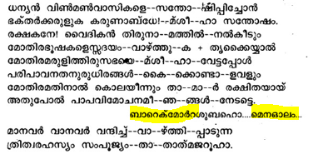
Priest | Pithruputhra parishudhathmavam daivame ! akashatheyum bhoomiyeyum..  Ivaril undavugeyum cheyaname.  Hosho….
People | AMEN.
CHOIR | 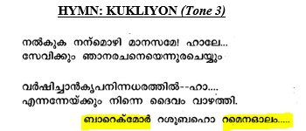
CHOIR | 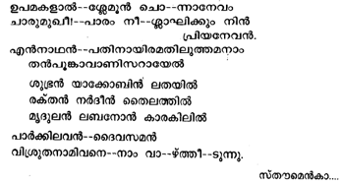
People | Kurielaison.
  - HUSOYO

Priest | Naam ella-verum prarthichu karthavin-nodu karunayum mono-guna-vum yachi-kennam
People | Karunya-van-aya karthave! njangal-ude mel karuna-cheythu njangalle sahayi-kename
Priest | Sthu-thiyum sthothra-vum prabha-vum pugazh-chayum manju-pokatha Nalla unna-thiyum ellay-ippozhum sadha-neethum eeda-vidathe karett-unvan njangal yogyar-ayi-thir-ename.
  - PROEMION

Priest | Vijathiyam puthriye thaniku…  Dhasarude mothiravazhvinthe ee samayathum…  Bhakalphun….
People | AMEN.
  - SEDRO

Priest | Manushyarude sarvapari…  ……  HOSHO….MENALOHO…
People | AMEN.
CHOIR M  F | 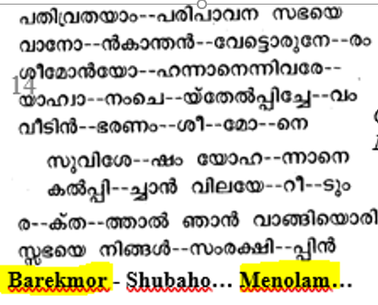  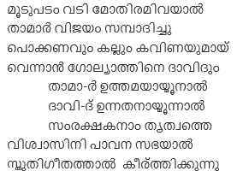
Priest | Morio rahem melenu adaren
  - ETRO

Priest | Prethinishtayum vedipumulla ….  Sthuthiyum sthothravum karettumaragename..(Rings are placed in the hands of the Priest for blessing)  HOSHO….
People | AMEN.
Priest | Thanthe karunayallum bahullamay..ruhaykum sthuthi.  (The Priest waves his right hand over the rings and says)  Vishudha sabhasanthanangallude…pithavintheyum+ puthrantheyum+…  BAREKMOR…BASHMO...
People | AMEN.
Priest | --
People | AMEN.
Priest | --
People | AMEN.
Priest | (The Priest turns to the west and gives the ring to the groom saying)  Daivamaya karthave
People | AMEN.
Priest | (The Priest turns to the west and gives the ring to the bride saying)  Daivamaya karthave
People | AMEN.
Priest | Prayer
People | AMEN.
Priest | Prayer
People | AMEN.
CHOIR M  F  M  F  M  F | 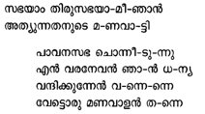  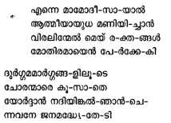  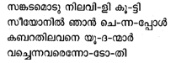  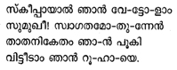
Priest | Morio rahem melenu adaren
  - FINAL PRAYER

Priest | Daivathal nidhigarikapeta…..  Ningalude kathukollukeyum cheyette.
People | AMEN.

  - PART II: Blessing of the crowns

Priest | Shubho…..
People | Bhala-heenarum pappi-galumaya  Njangalude mel karunayum manogunavum randu log-angallilum  Ennum-ennekkum choriya pedumar-agate.  AMEN.
Priest | Daivamaya Kartave ! njangalude santhoshathinthe arambavum…  Sthtuthiyum sthothravum karettumarakename  Hosho….
People | AMEN.
CHOIR | 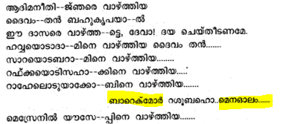
Priest | Morio rahem melenu adaren
Priest | Karthave parasparam bhandhitharayirikunna.. thirusanidhiyil ahladhikugeyum cheyumaragename.  Hosho….
People | AMEN.
CHOIR | 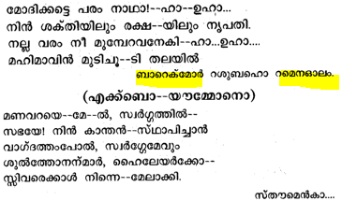
People | Kurielaison.
  - HUSOYO

Priest | Naam ella-verum prarthichu karthavin-nodu karunayum mono-guna-vum yachi-kennam
People | Karunya-van-aya karthave! njangal-ude mel karuna-cheythu njangalle sahayi-kename
Priest | Sthu-thiyum sthothra-vum prabha-vum pugazh-chayum manju-pokatha Nalla unna-thiyum ellay-ippozhum sadha-neethum eeda-vidathe karett-unvan njangal yogyar-ayi-thir-ename.
  - PROEMION

Priest | Undayirikunavannum…  Kiridengal ashirvadhikapeduna ee samayathum…  Bhakalphun….
People | AMEN.
  - SEDRO

Priest | Sakala swargiya senakallum…  ……sthothravum njangal karettunnu.  HOSHO….MENALOHO…
People | AMEN.
CHOIR  M  F  M  F  M  F  M  F | 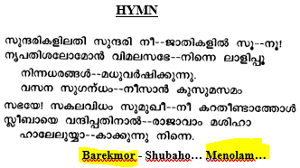  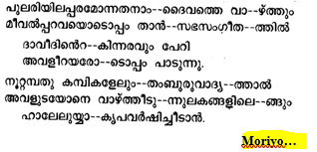
  - ETRO

Priest | Kothinne patanathil..  Karettugayum cheyumaragename  HOSHO….
People | AMEN.
CHOIR | Paulose sleeha Dhann-yan choll  Paulose sleeha Dhann-yan choll-  kette nith-evam  Ningale njangal-areecha-thozhee  Ching-oruvan van- ariyichal  Vanavan-engilum-adhoothan  Than-elkum sabha-yin shapam  Pala-thara-mupadheshangal-aho  Paril mulachu parakkunnu  Daivathinn upadesham-thott  Ava-sani-ppippon dhann-yan
Alter Boy  English: | Pari-shudhan-aya Paulose sleeha …..
Alter Boy  English: | The lesson from the Epistle of St. Paul, the Apostle, to  the.....- AHAI BAREKMOR.
People | Sleeha-yude udaya-vannu sthuthi-yum nammude-mel thanthe karuneyum ennekkum unda-yirri-kette.
Alter Boy | Ephesians 5: 20 – 6:3
CHOIR | 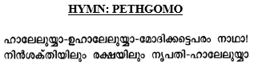

Alter Boy  English: | Barekmore,  Nam Adakka-thodum  bhaya-thodum  vannaka-thodum  Chevi-koduth nammude munb-akke  Vai-kka-pett-irrikunna nammude  Karthavu-eshu-mashiha-yude  Vishudha Evan-gelion-nile  Dheivathinthe Jeevan-ulla  Vachan-angalude ari-yippine  Namm kel-kenam.
Alter Boy  English: | With calmness and reverence and with sober minds, let us give heed, and listen to the Gospel of the living words of God, in the Holy Evangelion of our Lord Jesus Christ, that is read to us.

Gospel Reading – Evangelion
Priest | Shlomo….
People | Avi-duthe athmav-inodu koode  Daivamaya karthavu njangal-eyum yogyarakki theerku-mar-akette.
Priest | Jeevan nal-kunna prasan-gan-aya…….
People | Vanna-vanum varuvan-irrik-kunn-avanum ayavan vaztha-pettavan-akunnu. Nammude raksha-kkai thanne aya-chavanu sthuthi-yum nam-ella-varudeyum mel thanthe karunayum  Enneykum unda-yiri-kette.
Priest | Visudha kanyakamariamil........
People | Angane njangal vishwasi-chu ettu parayunnu.
Priest | [After the Gospel Reading]  NingaIk-kella-varkkum sam-preethi unda-yiri-kkatte.

CHOIR | 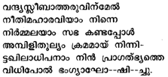
Hymn

Priest | (The Priest, waves his right hand over the crowns and says aloud.)  Pithavintheyum + Puthrentheyum +…  Purnamakapettirikunnu.
People | AMEN.
Priest | --
People | AMEN.
Priest | --
People | AMEN.
Crowning of the Bridegroom
Priest | 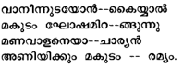
CHOIR | 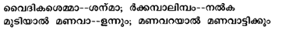
Priest | Kleelo…
CHOIR
Priest | Kleelo…
CHOIR | 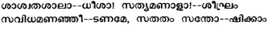
Priest | Nidhiyin kireedavum… HOSHO….
People | AMEN.
Crowning of the Bride
Priest | 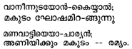
CHOIR
Priest | Kleelo…
CHOIR
Priest | Kleelo…
CHOIR | 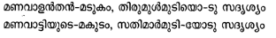
Priest | Nidhiyin kireedavum… HOSHO….
People | AMEN.
Groom now ties the pendant with cross (‘Thalli’).
Next the ‘Manthrakodi’ is vieled over.
CHOIR | 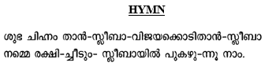  Cross, the sign of glory  Cross, flag of victory  We take pride in the Cross  That gave us sal-vation
Prayer for the Bride and the Bridegroom
Priest | Manushya jeevathathil..  Parishudharuhaykum sthuthi karettam.  HOSHO….
People | AMEN.
CHOIR M  F  M  F | 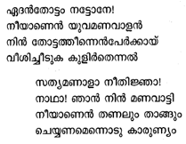  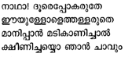  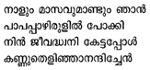
Priest | Morio rahem melenu adaren
CHOIR M  F  M  F  M  F | 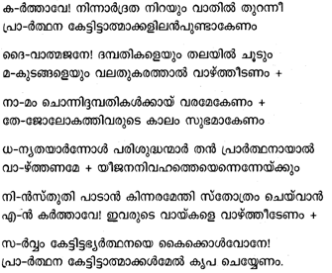
Final Exhortation & Joining of the Hands
Priest | (The Priest turns to the west)  Prayer
People | AMEN.
Priest | Swargasthan-aya Njangalude Pithave!
People | Ninthe Thiru-namam Parishudham-aga-pedename. Ninthe Rajyam Varename. Ninthe Thiru-vishtam  Swargathile-pole Bhoomi-yilum Akaname. Njangal-ku Avashyam-ulla Aharam Ennum njangalkku Tharename. Njangalude Kada-karodu Njangal kshamichathu-pole  Njangalude Kadan-galum Papan-galum njangalodu Schemi-kename  Pareek-shai-lekku Njangale Nee Praveshippi-karuthe  Pinneyo Dhushta-nil ninnu njangale Nee Rekshichu Kollename.  Enthu Konden-naal, Rajyavum, Shakthiyum, Mahathwavum,  Enney-kum Ninak-ulla-thakunnu  AMEN.
Priest | Kripa Niranja Mariame Ninakku Samadhanam
People | Nammude Karthavu Nin-odu Koode  Sthree-galil Nee Vazhtha-pett-aval-akunnu ninth udhara phalam-aya nammude Karthav-eshu Meshiha-yum vazhatha-petta-vana-kunnu.  Shudha – Mulla Kanyegha Martha Mariame, Thampuran-the Amme,  Papi-galaya Njangalkku- Vendi Ippozhum, Eppozhum, Njangalude Maranna Samayathum Daivam Thampuran-odu Apekshichu-Kollename.  AMEN.
Priest | Sarva-shakthi-yulla Pithav-ayi akasha-thinthe-yum bhoomi-yudeyum.
Alter  Boy  People | The Father Almighty maker of heaven and earth  and of all things visible and invisible  And in the one Lord Jesus Chirst  the only begotten Son of God  begotten of the Father  before all worlds  Light of Light  very God of Very God  begotten not made being of one substance  with the Father and by whom all things were made  who for us men and for our salvation came  down from heaven +  and was incarnate of the Holy Virgin Mary Mother of God  by the holy Ghost and became man +  and was crucified for us +  in the days of Pontius Pilate  and suffered and died and was buried.  And the third day rose according to His will  and ascended into heaven and sat on the right hand of the Father  and shall come again in His great glory to judge both the living and the dead  whose kingdom shall have no end  And in the one living Holy Spirit  the life giving Lord  of all who proceeds from the Father  and who with the Father and the Son is worshipped and glorified  who spoke by the prophets and the Apostles  And in the one Holy Catholic and Apostolic Church and  we acknowledge one baptism for the remission of sins  and look for the resurrection of the dead and the  new life in the world to come  Amen.  ***************************  Kanna-pedun-avayum  Kanna-pedath-avayum  Sakala-thinthe-yum Shrishta-vaya  Sathyega Dheva-thil Njangal vishwasi-kunnu.  Dheva-thinthe ekka-puthra-num,  Sarva-lokha-angalkum munbe  Pitha-vil ninnu jhani-ch-avanum,  Prakasha-thil-nin-ulla prakasha-vum, Sathya-Deva-thil nin-ulla sathya Dheva-vum, Jhani-ch-avanum shrushti-yala-thavanum,  Saram-shak-thil pithavin-odum
sammada-ulla-venum, Thanal sakala-vum nirmika-petta-venum, Manushy-ray Nammakkum nammude rakshay-kum vendi Thiru-manas-ay pragaram Swarga-thil-nin-irrangi + (Make the sign of the Cross)
Parishudha ruha-yal Dheva-mathav-aya vishudha kanyaka-mariya-mil ninnum shari-ri-ya-yi-thirnu manushay-ayi Ponthios Pilathos-in the divas-angalil
Nammuku-vendi + (Make the sign of the Cross) Kurushil tharey-ka-petta kashta-tha anu-bhavichu marichu adaka-petta moonam divas am uyir-thezhu-netta Swarga-thil-eku kareri + (Make the sign of the Cross)
Thanthe pitha-vinthe valathu-bhag-th irri-kun-avanum, Jeevan-ulla-vere-yum Marich-avereyum
Pidi-pan thanthe veliya mahathwa-thode Inniyum varuvan-irri-kuna-venum, Thanthe rajya-thwa-thin avasanam-illa-thavenum-aya-yeshu-mashiha aya Ega Karthavillum Njangal vish-wasi-kunnu.
Sakala-theyum Jeevi-pi-kunna karthavum, Pithavil ninnu pura-pettu, Pitha-vin-odum puthran-odum-koode Vandhi-ka-pettu sthuthi-ka-peduna-venum,
Nhibi-yen-marum sleehan-marum Moo-ghan-thiram sam-sarich-avenum-may Jeevanum vishudhi-yu-mula Ega ruha-yillum Katholi-kavum slei-hi-gavum
Ega vishuda sabhayulum Njangal vish-wasi-kunnu.

Pappa-mochana-thin mammo-dheesa Onnu mathrame-yullu
Ennu njangal ettu-paranja,
Marichu-poy-avarude
Uyer-pinnum Varu-van-irri-kunna lokha-thile Puthiya jeevan-u-mai
Njangal nokki par-kunnu.

AMEN.

Priest  Song | Ninnal sthuthi-yodu raja-makal  Haleluiah-vu-haleluiah  Nin valamai raja bhami-niyum
People-Song | Nin-nazha-karachan mohippan  Haleluiah-vu-haleluiah  Nin jana-mor-kayka pithru graha-vum,  BAREKHMOR.  Priest: Shubaho…  People: Menovollum vada-melavollum oll-mina-min
Malayalam Kurbana Kramam – Page 250
Priest  Song | Bhakthar pukazhcha bhajaname
People-Song | Ninnil-udi-chor-eka suthan  Thru-kkaral njangalil alivan than pakal-apeksha-yanay-kenam  Sthoumen kalos kurielaison

Priest  Song | Mariyamin smaranam vardaayakamaaka
People  Song | Thal prarthana njangal-kkathmavinu kotta  Barekmor  Subaho labo…  Daiva prasa-vithree kanya-ka mariya-min uyarun-noyaril  Sukha pari-mala dhoopam  Morio rahe-melai-noova-darain.  Moraneeso kurisum nin  Mathru janathin prarthanayum  Adikaleyum nin kopathin  Vadikaleyum mayicheedenam  OR  Nirth-ee-daru-the Mathave  Njangal-kay-ul-larthana-ye  Njangalil-ardratha thon-eedan  Yek-athma-jano-darthikka

COMMUNION OF THE PATRON AND OTHER SAINTS
Priest  Song | Nayavan pana pole  Thalir-thidume, Haleluiah  Valarum-avan lebanon Karakil-pol
People-Song | Vrudha-thayilum avar thalir-ittu  Thazha-chidume, Haleluiah  Vardhi-kum-avarkku thush-tee  Pushti-galum,  Barekmor.  Priest: Shubaho…  People: Menovollum vada-melavollum oll-mina-min
Priest  Song | Oru pol-ingum (Mor Ignatious)*  Unde melum ninnorma
People  Song | Utha-ganame nin prarthana nin  Ormaye bahu-mani-chorkkai,  Sthoumen kalos kurielaison
Priest  Song | Bhagh-yam nibiyar-kkum
People  Song | Bhagh-yam sleehar-kkum  Bhagh-yam sahadher-kkum  Puna-ru-dhana dhine,  Barekmor.
Priest  Song | Meshiha-ye kan-man
People-Song | Kamshi-choru sahader  Vallal chira-ku-kal poon-du  Unna-tha padam-eri  Morio rahem melenu adaren
Priest  Song | Parisudhan-mare ningal
People  Song | Prarthippin kartha-vodai  Adi-kaleyum than kopathin  Vadi-kaleyum mayi-cheedan.

People | Kurielaison..Kurielaison..Kurielaison  Njangalude Karthave!  Njangalod karuna cheyename.  Njangalude Karthave! Krupa-yundayee  Njangalod karuna cheyename.  Njangalude Karthave! Njangalude shushrooshayum prarthaneyum kaikond  Njangalod karuna cheyename.  Devame ninnaku sthuthi.  Srishtave Ninnaku Sthuthi.  Papikal-aya Ninthe Adiya-rodu  Karuna Cheyyunna Mashiha Rajave!  Ninakku Sthuthi -  BAREKHMOR
Priest | Swargasthan-aya Njangalude Pithave!
People | Ninthe Thiru-namam Parishudham-aga-pedename. Ninthe Rajyam Varename. Ninthe Thiru-vishtam  Swargathile-pole Bhoomi-yilum Akaname. Njangal-ku Avashyam-ulla Aharam Ennum njangalkku Tharename. Njangalude Kada-
Malayalam Kurbana Kramam – Page 282
karodu Njangal kshamichathu-pole Njangalude Kadan-galum Papan-galum njangalodu Schemi-kename
Pareek-shai-lekku Njangale Nee Praveshippi-karuthe
Pinneyo Dhushta-nil ninnu njangale Nee Rekshichu Kollename.
Enthu Konden-naal, Rajyavum, Shakthiyum, Mahathwavum,
Enney-kum Ninak-ulla-thakunnu
AMEN.
Priest | Kripa Niranja Mariame Ninakku Samadhanam
People | Nammude Karthavu Nin-odu Koode  Sthree-galil Nee Vazhtha-pett-aval-akunnu ninth udhara phalam-aya nammude Karthav-eshu Meshiha-yum vazhatha-petta-vana-kunnu.  Shudha – Mulla Kanyegha Martha Mariame, Thampuran-the Amme,  Papi-galaya Njangalkku- Vendi Ippozhum, Eppozhum, Njangalude Maranna Samayathum Daivam Thampuran-odu Apekshichu-Kollename.  AMEN.

